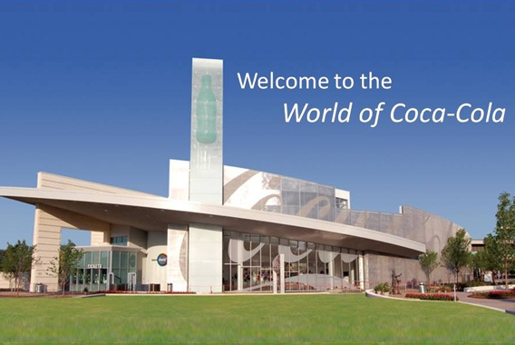

COCA-COLA AVENUE STAMFORD
BRIDGE LONDON SW1V 3DW
UNITED KINGDOM
E-MAIL: moneyclaims5uk@gmail.com
Tell: +447014235755
Dear Lucky Winner,
This is to inform you that you have won a prize money of £500,000.00(Five Hundred Thousand Pounds) for the Yearly Coca-Cola Lottery promotion United Kingdom which is organized by Coca-Cola in conjunction with Chevron Texaco Oil and Gas Company, “Your Email Address" were selected through a computer ballot system drawn from Nine hundred thousand email from Canada, Australia, United States, Asia, Europe, Middle East, Africa and Oceanic as part of our international promotions program which is conducted annually, we have only selected 20 people as our winners, through electronic ballot System without the winner applying.
These are your identification number :
Ticket Number: 011425896/2014
Serial Number: 3872/506
Lucky Numbers:7/4/88/28/01/40
BELOW ARE THE REQUESTED INFORMATION'S;
1. Full Names:
2. Full Home Address
3. Gender
4. Nationality:
5. Age:
6. Current City:
7. Occupation:
8. Mobile Number:
9.E-mail Address:
10.language spoken :
MAKE SURE YOU REPLY BACK TO THIS E-MAIL:
moneyclaims5uk@gmail.com
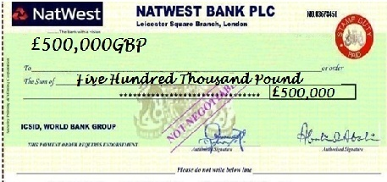
APPROVE PAYMENT OFFICER: DR.HENRY MARK Tel: +447014235754
-mail- moneyclaims5uk@gmail.com
make sure you reply back to this e-mail:
moneyclaims5uk@gmail.com Congratulation Once again FROM THE BOARD DIRECTORS
